GET TIMER, OPEN HAMUNDS HARVEST TABLE!!!

Set Map for green hag battle

*Recap: It has been mere weeks since the adventure began for Nasoj, the brave and compassionate half-elf Fighter; Elana, the stoic half-elf druid; and Vahalla, the fierce Tiefling Barbarian. They started their adventure in the quiet town of Swallow’s Song, on the edge of the deadly Storm Rage Mountains. In the pub, Nasoj met 3 dwarves, who he shared drinks with. Just as they were settling in, a hoard of zombies descended ominously upon the town, burning it to the ground as they headed up to the Talos Temple. A dark wraith joined them in their villainous crusade and rendered our adventures useless.*

*They were able to flee to the prairie cities, Silver Rose. There, they met inn keepers, a Bard named Ella, a Rouge named Kallista, and a Talos priest named Taoba. They learned of a necromancer who may be the cause of the zombie attacks. It is possible the necromancer came from the Tiefling village in Demon’s Hearth desert, where Vahalla is from.*

*They ended up fighting a wererat in the sewers of Silver Rose, where Nasoj was bitten by the rat, to save sick and orphaned children, they unnecessarily adopted all 10 orphans and left them with the innkeepers David and Mary Margaret. Then, our adventures headed to the elven city of Thels Dorei to return a wedding ring to the widowed Ayana, per Mary Margaret’s request.*

*After days of walking, nearly being devoured by giant roses, meeting a fearless pixie named Basil, visiting a beautiful but unfriendly village called Serenity Gardens, Vahalla acquiring a fungal infection, navigating a haunted mansion, nearly killing a rouge named Jade, and meeting the vampire Celestine, they arrived at their destination.*

*Kastor, the village elder and Ayana’s distant grandfather, informed the adventurers that Ayana had been kidnapped by dwarves, living in the Storm Rage Mountains. With the promise of reward, our adventures took off to the mountains. First, they traveled to meet the Mycondids of the underdark to find a potion to cure Vahalla’s fungal infection.*

*They briefly met a drunken dwarf named Torg, but Torg disappeared shortly after arriving at the mountains. Ayana was there with her newly born son, and informed them that she hadn’t been kidnapped at all. The dwarves had saved her from a hoard of zombies. She gave birth shortly after and was unable to travel home.*

*Additionally, they met a crazy Wizard who looked like he was a combination of a bunch of different body parts being sewn together, and was named Patches. He had a pseudodragon familiar named Puff. Nasoj found out he had a daughter, Arys, and a baby mama. Nasoj also met up with an old dwarf friend from the fighter’s guild, Thu’mer. Vahalla became known as the Wraith Slayer due to the innocently overexaggerating dwarves that they met in Swallow’s Song. Nasoj, one moonlit night, felt the spell of lycanthropy as he transformed into a wererat and nearly killed his baby mama and daughter. Luckily, Patches was able to create a set of earrings to help control the lycanthropy, and was able to restore Nasoj’s stone hand (which we wont talk about) to normal. They also met up with Ella and Kallista, who were searching for a Talos relic for Taoba. After Nasoj got to the relic and took it, the girls have decided to return to Taoba in Silver Rose with the group.*

*Eventually, they left the mountain to return Ayana and her baby Glyn, to Thels Dorei. On the walk, they were robbed of food by a Night Hag, and were drawn to the sweet smell of a stew. Little did they know that the stew was being made by an Ogre who planned on eating a little Wizard Gnome, Willum, for dinner. Nasoj was able to single handedly kill the ogre and free the Wizard. Having nothing better to do, the Wizard decided to go back to Silver Rose with the adventurers.*

*So now we have Nasoj, Ella, Vahalla, Willum, Kallista, Ella, and Thu’mer. They very quickly and uneventfully dropped Ayana off at Thels Dorei, and marched through the Serenity Gardens (which had been mutated due to a potential demon living nearby, which they found out thank to Willum), they were recruited by another Pixie, Styx to save Basil who went to talk to the King of Feywild about the Demon problem. She has not come back.*

*The party, excluding Thu’mer, who doesn’t like magic, and Kallista, who doesn’t like people, joined Styx in going to the Feywild, a world of fairies and everlasting magic.*

*There, they bought some provisions in a Saytr village, easily avoiding any come ons by the promiscuous creatures, and began walking towards the floating city of StarDust. It should be noted that emotions are heightened in this magical world.*

*The party met a Boggle, who is now bff’s with Nasoj. The city of StarDust only has one entrance for those who cannot fly. You must walk to the center of the crater under the city (where the city lifted from) and walk up a giant, glass-stone, spiral staircase. The party made their way down the crater, where they split into two groups.*

*Nosaj and Ella chased the Boggle into a Crystal Cavern, where they fought a few pale goblins and almost died at the hands of a Crystal Golem. With the help from the Boggle, the group was able to kill the Golem, and retrieve a dark sword from it’s body, called Bane of the Fey.*

*Now, we join Willum, Vahalla and Ella as they travel through a bramble, attempting to reach the staircase.*

Talk about actions and readying attacks and stuff

# Bramble path:

The bramble can be removed through cutting or through fire, but too strong of fire will catch everything on fire.

*Will need to escape the fire.*

***Play Creepy Swamp Music***

You enter a boggy forest, but the presence of magic has twisted the land in wonderful ways. The moist earth below your feet gives way as you take each step. Water fills your footprint and begins to soak into your shoes. The water is a silvery color. The trees are nearly completely gray-white with bluish green leaves. The limbs and trunks of the trees curve, twist and curl.

Green vines with purple leaves are growing up the sides of the trees and hang off limbs like patient snakes. Fireflies occasionally flicker on and off, providing very little light. The swamp has a peculiar smell that is especially bothersome to Nasoj.

It should be noted that it is very dark in this area. The floating city casts an ominous and permanent shadow over the swamp. The trees further obscure your vision overhead, completely clouding the glass staircase. The magical effects of the Feywild are adding even to your feeling of uncertainty, encouraging you to act impulsively.

A shiver runs through Elena’s body, making the hair on her arms and back of her neck stand up momentarily.

**What do you do?**

Perception Check or Survival Check (whichever is higher) DC 12

You notice a pair of footprints headed in the same direction of you. They are small, but not those of a child.

**What do you do?**

You notice a young girl up ahead. She looks elven but young, like a teenager. She is wearing a short, green dress. With a loosely tied brown belt around it. Her short brown hair is decorated with a braided rope (the thing that goes around hippy girl’s heads that I can’t wear cause they’re stupid). Her face, hair and clothing is strangely clean.

She is unsuccessfully hiding behind a white tree, peering curiously at you. When she sees you’ve notice her, she takes off into the swamp.

***Play Walpurgisnacht***

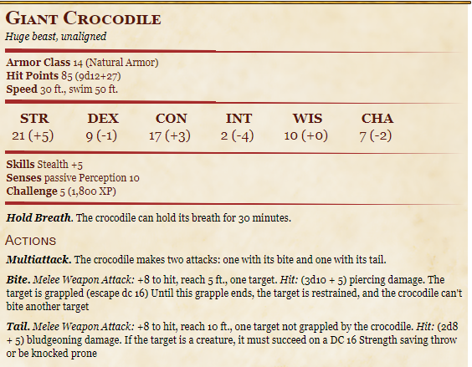**What do you do?**

If they follow her, then passive perception of 13.

If fail, you fall into a boggy mess. A large splash stops your ripples as a large bluish creature (croc) rushes you in the water.

You are surprised and cannot react (low initiative).

Others can roll for initiative.

You see the young girl watching you. She looks curious of your presence. When she notices you watching her, she takes off again.

Walk more

The maiden is still watching you. She is smiling now, amused and curious of your behavior.

**What do you do?**

# Hag House

The maiden runs off, her eyes playfully encouraging you to follow. She moves gracefully through the swamp; she obviously knows this area very well.

At this point, you are completely lost in the woods. Your footprints leading behind you have seemed to be absorbed back into the earth. Nothing looks that familiar; you’ve been traveling for a while now (maybe) and are growing tired.

**What do you do?**

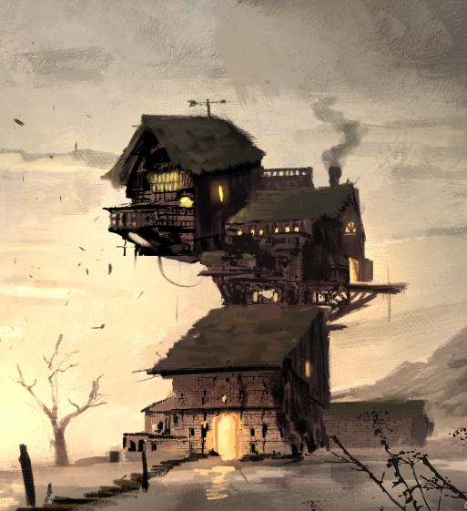Up ahead, there is a house (describe it or show photo).

The girl runs up the steps into the house. She smiles at you over her shoulder before running into the house.

**What do you do?**

You enter the house…The door slams shut behind you and you hear a faint click as the door locks.

***Play Gruntilda’s Liar***

The house is incredibly dirty and smells of rot. You see several items around the room:

SAY: A sickly raven in a bird cage yells insult at you as if you are a hang (aka mimicking hags). Also yells “Hansel! Don’t die! Handsel!” and “Shut up! They’ll never find you!”

## Items

* A jar full of eyeballs; they move and look at you
* A Shrieker plant in a pot (if you touch is it shreaks at you very very loudly)
* A chest with an ungodly amount of sweets
* A silver bell that casts Toll of the Dead once a day (will automatically hurt one of the others)
* A copper ring with rat bite marks in it.
  + Cursed. Any time the user retrieves an item out of their bag, a copper spoon that has been gnawed on by rats is there. They can get rid of it, but it always re-appears. Any bag. Anywhere. If they go to get the spoon or intend to grab the spoon, it disappears.
  + Must use remove curse spell in order to take off ring.
* A wooden ring
  + Cursed. Makes you feel the need to close every door behind you, even if someone else is still walking through. Must not wear the ring for 3 days for curse to be broken.
  + Burning the ring will remove curse. Breaking ring will not.
* A ring that glows purple (attune) Ring of Paranoia
  + Once a day you must roll a wisdom check. The lower you roll, the more paranoid you become.
  + If under 10, disadvantage on wisdom and charisma, but +10 to insight and perception checks.
  + If over 10, +1 to insight and +1 to perception checks.
* A clearish blue ring with bubbles in it (attune)
  + Allows you to breath freshwater.
* Molten lava ring (attune)
  + Grows hot when 120ft from a fiend.
  + Additional 1d8 radiant damage to all fiends with any weapon.
* Half a beehive covered in infernal writing saying, “Bael”. When the honeycomb is broken, an imp pops out.
* A skull whose jaw is moving like it is trying to speak
  + Cursed. Cannot control volume of speech. Each time you speak roll D6. D1 = nearly inaudible whisper, D6= screaming.
  + Broken by giving to someone else who has never had it. Condition, must have a mouth and be animated.
* Three metal balls sitting on a wooden plank
  + Cursed. Must repeat the last word of each sentence you speak 3x, progressively getting softer.
  + Broken by repeating the last sentence they muttered without having to repeat it.
* A jar with an overweight toad stuffed in it. It sings a lullaby when you pick it up, it makes you very sleepy… It’s also a prince if remove curse is used
* A bird’s cage containing a rat
  + Actually Elizabeth
* A shattered mirror. If you look in it, you have become old and disgusting. But a hag would look beautiful.
* A cracked hand mirror that shows a shadowy figure standing behind you. The figure doesn’t interact with you or seem dangerous.
* A child’s doll, missing a button eye, torn a bit and very dirty.
* Voodoo dolls that look just like the PCs
* 2 blank voodoo dolls and a recipe book for making voodoo dolls in Slyvan language
* A black and gray feather quill and black ink. When writing someone’s name, it makes them shiver. Several names are written in the book. Elena’s name has recently been written in the book. You can momentarily see through their eyes (like 2 seconds).
* The skeleton of two child-sized humanoids in separate but close cages. They are holding hands through the bars.
* Wall hangers that hold coats, towels, cups, etc. They are hands from random species…
* 3 potions that have the same consistency and color as greater healing potions. (they are greater healing potions).
* A taxidermy beholder being used as a chandelier.
* A desk with cut up animal parts, like chicken feet, raven feathers, frog legs, etc.
* A pair of large butterfly wings, with straps like a backpack
  + Turns into unremovable wings while in Feywild. In the material world, will turn back into a ‘backpack’ and will not function. Will flutter and let you hover but cannot fly fly.
* A book with fey depictions on it. It is bound with a green belt.
  + Reader gets a searing pain in their mind. They now understand Slyvan and can read it.
* A book with demon depictions on it. It is bound with a red belt.
  + Reader gets a searing pain in their mind. They now understand Abyssal and can read it.
* A brass teapot with ancient scribblings
  + A Djinn comes out and offers you 3 wishes (must follow the Wish spell)
* Parchment
  + Written in Slyvan. It talks about how to enchant weapons. It discusses how enchantments work and that they can fit into slots on properly crafted weapons. It gives a breakdown of how these weapons can be forged. It also talks about how to bond enchantments to the weapon.
* A book with a door on it
  + It is hallowed out and a key falls out of the book.
* A book with a hag riding a Broom. It is written in common and is called Baba Yaga
  + Baba Yaga is a supernatural being who is a ferocious hag. She flies around in a mortar, wields a pestle, and dwells deep in the forest in a hut that walks around on two chicken legs. Although she is very in tune with forest wildlife, she will eat children who come to her house.
* A fairytale book about Merlin.
  + Talks about the most powerful wizard that ever lived. He created Caster Hills, a magic community 1,000 years ago, after defeating Valcarion, the red dragon.
  + As an alchemist, he was able to create powerful potions that could reverse almost any condition or break any curse. Some said his potions could even bring loved ones back from the dead.
  + Merlin was obsessed wit
  + He was renounced for his ability to defy death, but it was unsure how he did it. It said his face grew old, despite his powerful magic, and so he hid it under his cloak 700 years ago. No one has seen him since.
* A silver dagger (no bonus other than it is silvered).
* A rolled up scroll (wizard cantrip)
* Potions 1d6
  + remove all effects of all spells and curses, good or bad,
  + gives you terrible stomach pains
  + makes everything taste like birthday cake. Lasts 1 week
  + Makes you super alert (+3 to perception for 1 day)
  + Makes your skin as strong as iron, but everything tickles (resistant to bludgeoning, piercing, and slashing)(disadvantage on reactions or anything involving touch)
  + Makes your tongue swell up and become numb so speaking is difficult.

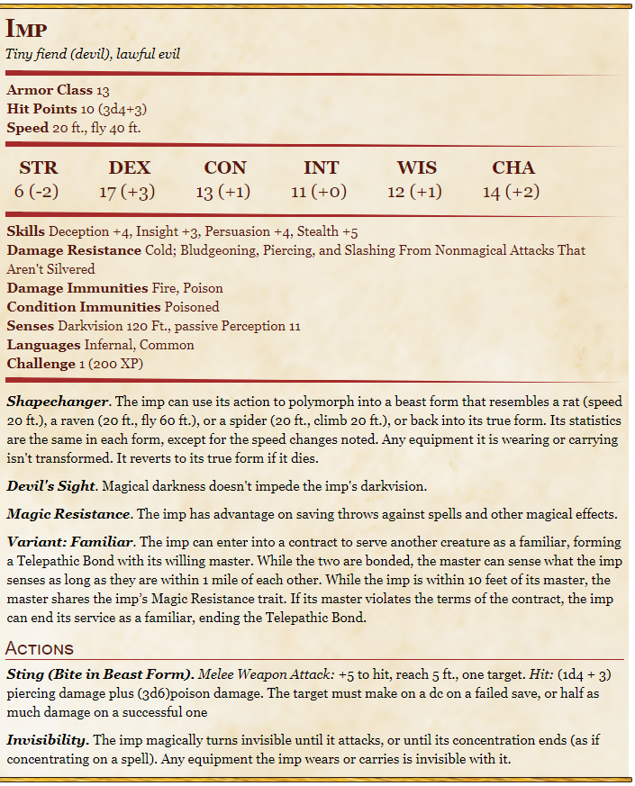

**Toll of the dead:**

You point at one creature you can see within range, and the sound of a dolorous bell fills the air around it for a moment. The target must succeed on a Wisdom saving throw or take 1d8 necrotic damage. If the target is missing any of its hit points, it instead takes 1d12 necrotic damage.  
The spell’s damage increases by one die when you reach 5th level (2d8 or 2d12), 11th level (3d8 or 3d12), and 17th level (4d8 or 4d12).

Additionally, there is a ladder going up, but is blocked by a trap door. There is also a door near the back of the room, by the cauldron. (it is locked)

**What do you do?**

## Basement

Once they have the key and try the back door.

The door opens and reveals a moist stone staircase leading into a basement of some sorts. The walls are damp and moss is growing on the stone.

A wicked laugh erupts through the staircase.

**What do you do?**

The basement is incredibly dark, like it’s been shroud in magical darkness, and dank. Even with dark vision, you cannot see anything. As you walk, you feel a pressure on you. The wizard and druid feel it more than the others.

The air is frigid, but humid. The icy moisture in the air clings to your skin. It reeks of swamp.

As you get to the bottom, someone runs into what feels like a chain that is in a U shape dangling from the ceiling. The floor at the bottom is rickety, like an old dock.

If they try to light a torch, it illuminates the room for an instant and then is immediately put out, as if by magic.

Any spells that create light are severely dampened. It illuminates the room for an instant and then fades severely down. So, the item or whatnot might still glow, but it provides only 2 ft of light. The pressure gets worse and you feel exhausted.

However, DC 15 perception to see a lever on the other side of the room with the light.

**What do you do?**

If they pull the lever. The pressure you were feeling is lifted.

Torches immediate illuminate the room. The room is circular with no way out, except the stair case, which just had an iron gate come crashing down in front of it, blocking off your escape route. It is a very large room.

The floor is a wooden disk made up of ‘slices’ of alternate wood. Every other one is dark oak, or light oak. Between the slices, you can see a pool of murky water about 15ft below. If you listen closely, it sounds as if something could be moving

One of the ugliest women you’ve ever seen falls from the ceiling. Her skin is a sickly shade of green, and her face is covered in warts. The few remaining teeth she has are extremely yellowed and crooked.

She lands surprisingly gracefully in the center of the room. You hear a loud but low creaking sound and the wooden floor seems to dislodge from unseen restraints at the hag’s weigh. The floor begins to tilt violently in the direction you are all standing. The Hag continues to stand on the center, unmoving.

### HAG

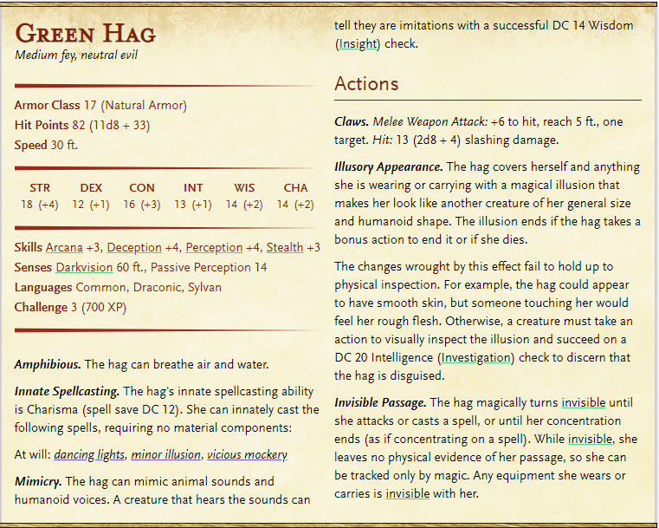

***Dungeon Defenders II***

**Vicious Mockery:** You unleash a string of insults laced with subtle enchantments at a creature you can see within range. If the target can hear you (though it need not understand you), it must succeed on a Wisdom saving throw or take 3d4 psychic damage and have disadvantage on the next attack roll it makes before the end of its next turn.

**Roll for initiative**

Here’s how it works (at the end of each turn):

Round 1 – The floor is tilting. DC 16 dex or lose a turn to balance. The hag recovers from her fall. The floor will click into place once it is stabilized. (dex 12 check to keep balance each turn until stabilized. Then hit roll, then attack roll)

After round 1 the hag will start using Vicious Mockery to lower your HP.

Round 3 – You feel a rumble beneath your feet.

Round 4 – the dark slices drop 10ft. All the slices begin to rotate: light oak clockwise, dark oak, counterclockwise. Sharp sickles protrude from the bottoms of the light oak.

Anyone on the dark oak – DC 10 dexterity. 6d4 (6 slices) (roll dex 3x. each fail is 2d4 damage) disadvantage on the first for being confused. Advantage on the last for getting good at this. Crit fail = max damage and fall in water. Crit success and do not need to roll anymore.

Light people who readied a reaction get to attack with advantage on this turn.

Round 5 – still rotating. Light oak people get to attack.

Round 6 – Dark oak rises back up. DC 12 or roll with disadvantage (dark oak only)

Round 8 – The lights go out. Someone must flip the lever back on. (disadvantage on attack rolls, advantage for the hag on attack rolls). She moves in the dark.

Round 11 – You hear a loud but low creaking sound.

Round 12 – The floor is dislodging and starts tilting again. Dex check DC12

Must stabilize again. If you readied an attack, you have advantage on your saving throw and do not lose any action. Failed, you lose a turn. Succeed, you keep your action, but have disadvantage on attacks.

The hag does not attack this turn.

Round 14 – you feel a rumble beneath your feet.

Round 15 – the dark slices drop 10ft and begin to rotate. (no disadvantage this time)

Round 17 – Dark oak rises back up.

Round 20 – The lights go out.

Round 23 – You hear a loud but low creaking.

Round 24 – The floor is dislodging and starts tilting again.

The hag begins to shrink, and you’re left with an ugly hag plushie in the middle of the floor. The plushie has a key around its neck.

Upon taking the plushie, a golden light starts to illuminate as an arch on the wall. A door is magically carved into the wet stone.

HAMUND’S GUIDE!

## Bed Time

### Vampire

*Medium undead (shapechanger), lawful evil*

* **Armor Class**16 (Natural Armor)
* **Hit Points**144 (17d8+68)
* **Speed**30 ft.

**STR DEX CON INT WIS CHA**

18 (+4) 18 (+4) 18 (+4) 17 (+3) 15 (+2) 18 (+4)

* **Saving Throws**Dex +9, Wis +7, Cha +9
* **Skills**Perception +7, Stealth +9
* **Damage Resistance**Necrotic; Bludgeoning, Piercing, and Slashing From Nonmagical Attacks
* **Senses**Darkvision 120 Ft., passive Perception 17
* **Languages**The Languages It Knew In Life
* **Challenge**13 (10,000 XP)
* ***Shapechanger***. If the vampire isn't in sun light or running water, it can use its action to polymorph into a Tiny bat or a Medium cloud of mist, or back into its true form. While in bat form, the vampire can't speak, its walking speed is 5 feet, and it has a flying speed of 30 feet. Its statistics, other than its size and speed, are unchanged. Anything it is wearing transforms with it, but nothing it is carrying does. It reverts to its true form if it dies. While in mist form, the vampire can't take any actions, speak, or manipulate objects. It is weightless, has a flying speed of 20 feet, can hover, and can enter a hostile creature's space and stop there. In addition, if air can pass through a space, the mist can do so without squeezing, and it can't pass through water. It has advantage on Strength, Dexterity, and Constitution saving throws, and it is immune to all nonmagical damage, except the damage it takes from sunlight.
* ***Legendary Resistance (3/Day)***. If the vampire fails a saving throw, it can choose to succeed instead.
* ***Misty Escape***. When it drops to 0 hit points outside its resting place, the vampire transforms into a cloud of mist (as in the Shapechanger trait) instead of falling unconscious, provided that it isn't in sunlight or running water. If it can't transform, it is destroyed. While it has 0 hit points in mist form, it can't revert to its vampire form, and it must reach its resting place within 2 hours or be destroyed. Once in its resting place, it reverts to its vampire form. It is then paralyzed until it regains at least 1 hit point. After spending 1 hour in its resting place with 0 hit points, it regains 1 hit point.
* ***Regeneration***. The vampire regains 20 hit points at the start of its turn if it has at least 1 hit point and isn't in sunlight or running water. If the vampire takes radiant damage or damage from holy water, this trait doesn't function at the start of the vampire's next turn.
* ***Spider Climb***. The vampire can climb difficult surfaces, including upside down on ceilings, without needing to make an ability check.
* ***Vampire Weaknesses***. The vampire has the following flaws: Forbiddance. The vampire can't enter a residence without an invitation from one of the occupants. Harmed by Running Water. The vampire takes 20 acid damage if it ends its turn in running water. Stake to the Heart. If a piercing weapon made of wood is driven into the vampire's heart while the vampire is incapacitated in its resting place, the vampire is paralyzed until the stake is removed. Sunlight Hypersensitivity. The vampire takes 20 radiant damage when it starts its turn in sunlight. While in sunlight, it has disadvantage on attack rolls and ability checks.

#### Actions

* ***Multiattack (Vampire Form Only).*** The vampire makes two attacks, only one of which can be a bite attack.
* ***Unarmed Strike (Vampire Form Only).*** *Melee Weapon Attack:* +9 to hit, reach 5 ft., one creature. *Hit:*(1d8 + 4) bludgeoning damage. Instead of dealing damage, the vampire can grapple the target (escape DC 18)
* ***Bite (Bat or Vampire Form Only).*** *Melee Weapon Attack:* +9 to hit, reach 5 ft., one willing creature, or a creature that is grappled by the vampire, incapacitated, or restrained. *Hit:*(1d6 + 4) piercing damage plus (3d6) necrotic damage. The target's hit point maximum is reduced by an amount equal to the necrotic damage taken, and the vampire regains hit points equal to that amount. The reduction lasts until the target finishes a long rest. The target dies if this effect reduces its hit point maximum to 0. A humanoid slain in this way and then buried in the ground rises the following night as a vampire spawn under the vampire's control
* ***Charm.*** The vampire targets one humanoid it can see within 30 ft. of it. If the target can see the vampire, the target must succeed on a DC 17 Wisdom saving throw against this magic or be charmed by the vampire. The charmed target regards the vampire as a trusted friend to be heeded and protected. Although the target isn't under the vampire's control, it takes the vampire's requests or actions in the most favorable way it can, and it is a willing target for the vampire's bit attack. Each time the vampire or the vampire's companions do anything harmful to the target, it can repeat the saving throw, ending the effect on itself on a success. Otherwise, the effect lasts 24 hours or until the vampire is destroyed, is on a different plane of existence than the target, or takes a bonus action to end the effect.
* ***Children of the Night (1/Day).*** The vampire magically calls 2d4 swarms of bats or rats, provided that the sun isn't up. While outdoors, the vampire can call 3d6 wolves instead. The called creatures arrive in 1d4 rounds, acting as allies of the vampire and obeying its spoken commands. The beasts remain for 1 hour, until the vampire dies, or until the vampire dismisses them as a bonus action.

#### Legendary Actions

Vampire can take 3 legendary actions, choosing from the options below. Only one legendary action option can be used at a time and only at the end of another creature’s turn. Vampire regains spent legendary actions at the start of their turn.

* **Move.** The vampire moves up to its speed without provoking opportunity attacks.
* **Unarmed Strike.** The vampire makes one unarmed strike.
* **Bite (Costs 2 Actions).** The vampire makes one bite attack.

Describe room, couple candles, rug, several beds.

If they try to sleep anywhere else, they wake up every few minutes with the feeling they are being watched.

You awake to a very unpleasant noise, like metal sliding across stone. You are well rested, despite the abrupt wake up. The room is still dark/dim, but you can see a faint light leaking through in a square on the wall opposite to the door.

**What do you do?**

The wall moves out of your way…you think. Maybe you’re a little hazy from sleep.

A light fog slithers across the floor as you gaze into a hallway. The walls are dark, like obsidian, with nearly matching floors. The hallway itself is unlit, but you can identify a room at the end of the hall by the dimly glowing candle light.

As you enter the room, 3 of you are shocked as memories come rushing over you. The floor, the lighting, seem all too familiar.

**But from where?**

It is the final room you entered in the moving mansion. Haunting music floods the air as a shadowy figure emerges from the back of the room. A beautiful man (describe celestine) steps from the shadows, his white fangs protruding from his ruby lips.

“Welcome back” he says, his words sharp like razors.

*banter*

talk about the scepter they found that has the vampire on it. (once magic is unlocked they could control Celestine, but not in the dream anyway).

Talk about how they haven’t taken the necromancer down.

Talk about how the necromancer is going to give him the ability to walk in the sun permanently with the power of the scepter and immunity to running water.

Talk about how he will benefit from ‘the new world’ when humans will seek out his protection from the undead in exchange for their blood.

*/banter*

“I was concerned your crusade would become problematic, but it’s apparent that you neither have the desire nor organization to cause any real problems from the necromancer. Besides, you have already found the scepter for me. Your usefulness is growing thin. I will agree to let one of you live if you hand over the scepter immediately. Otherwise, I will take it from your corpse.”

**Battle**

**How it works**: SHHHHH! as they die, pass them a note saying they awake in the bedroom, with everyone in their bed. The passageway is still open. As you proceed down the hall, made of wood and stone, not obsidian, you see a hideous purple woman in the middle of the room. She seems to be concentrating on a spell.

(but she does not attack until everyone is awake. If they kill her while she’s still concentrating, she will not attack at all). If she kills everyone first, then she will heal and you’ll have to kill a hag. If you kill her first, everyone wakes up.

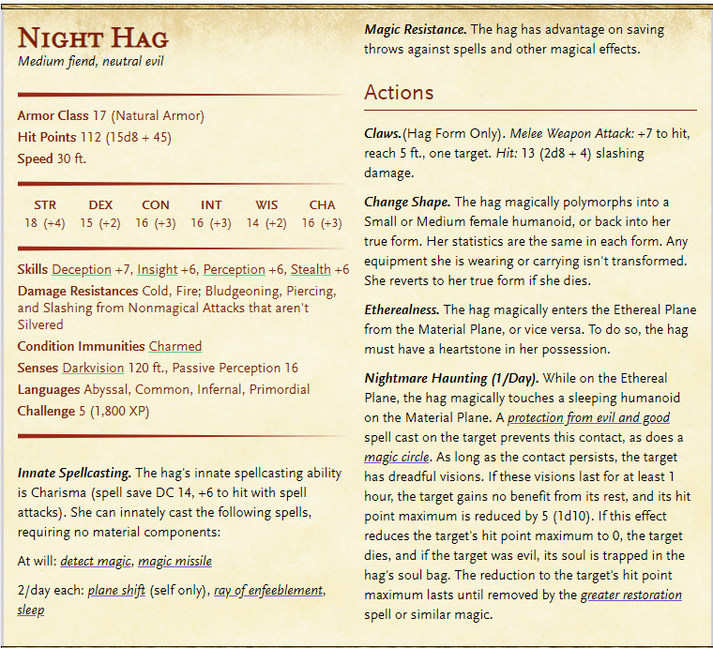

Each time you hit her, you notice the amulet glowing a little brighter. Magical necklace that heals 1d6 every turn.

She is lowering their HP max. -5 for every 20 min.

## Jungle Time

**What do you do?**

You enter a room full small, wood carved animals.

**Dexterity**:

Monkey   
Lemur

**Charisma**

Macaw

Raven

**Strength**

Gorilla

Bear

**Constitution**

Salamander

Seahorse (if it doesn’t suffocate)

Frog

**Wisdom**

Rat

There is a door at the end of the hallway.

It is locked until everyone picks up an animal.

You are now in a small room with a door on the other side. The door behind you locks and the one in front of you unlocks once everyone is in.

**African Folk Music**

You are in another room, but this room is obviously enchanted. The entire room is a rain forest! The rain lightly taps the forest floor.

{explain how they’ve each changed}

They can exit the room and change back but they must ALL be in the small room. They can change their animal as desired.

### Dexterity

There is a large ravine in front of you (It’s very deep and wide.). On the far edge, you see a staircase leading down to the ravine from your side, but there is not a stair case leading up to the other side. The tree ahead is barely resting on the branch of the living tree.

You’ll need to send someone over to push the dead tree over the ravine for the other animals to get across.

### Constitution

There is a large wooden barrier with a keyhole in the center. You must swim to the bottom of the pond to retrieve the key, The pond is incredibly deep (drowning after 1+const mod)(then save throw)(if you survive your save throw, you immediately start saving throws again) The keyhole is dripping water. The pond is lit up by glowing algae but it is still a maze.

### Intelligence

There is a tiny hole in the middle of the stone ground, about 6” in diameter. A small animal may be able to fit through it. At the bottom of the hole, a larger room awaits, but is still small. A wooden box with a with a 2-option number spinner. The box is too big to fit through the tiny passage you just came through. The room is incredibly hot (dries out amphibians).

On the top of the box it reads

“Double my number, I’m less than a score,  
Half of my number is less than four.  
Add one to my double when bakers are near,  
Days of the week are still greater, I fear.”

The box pops open and a key is present.

### Wisdom

There is a dark cave off to the side. The cave is pitch black. Bat can use echolocate or firefly can light the way (but still very dim lighting so would need something like an owl too)

### Charisma

There is a door. A sign hangs next to it saying, “Sing me a lullaby”, “Sing me a fast song”,   
“Sing me a love song”, “Sing me a song about witches or wizards”.

### Strength

You enter a maize like canyon, with thick, red rock walls, with a map hung on the wall. It depicts 4 boulders and 4 “x marks the spots”. As you look straight ahead, a part of the rock has been worn (a donut), probably over the centruries or by magic, just enough that you can clearly see an iron gated door at the end.

You’ve entered a new room, with 6 treasure chests. Each chest has the animal you once were. The boggle with the toad is anxiously awaiting your arrival. The boggle seems a little scared, but is happy to see you.

The animal carvings have stayed with you.

### The Annis Hag

You hear loud, heavy footsteps nearby.

The room around you begins to creak. Your eyes dart back and forth as the room begins to expand. Trees begin sprouting up from the floor, turning into jungle trees within minutes. A small waterfall erupts from the wall behind you, and vines come tangling down the branches above your head.

“Oh who could be in the jungle with me?

A rat, a bat, or another tasty snack?

I’ll crush its bones and eat its eyes,

For their limbs, I liked them fried”

The newly found jungle shakes under the weight of whatever is in the room with you.

“I’ll boil it’s brain and drink it’s blood

Eat the liver seasoned with mud.

I’ll eat their fingers while they’re still alive.

Make them plead and beg to die.”

You catch a glimpse of something monstrous through the trees. Its skin looks sickly blue, with boils covering its arms. Its tiny head sits upon an enormous hunchback that brushes the bottoms of the trees. Its arms look the size of small tree trucks with long, disfigured claws at the end.

“And from their teeth I’ll make some tea,

I’ll carve their lungs so they can’t breathe.

And when they’ve been all torn apart,

For dessert, I’ll eat their heart.”

The ground grows quiet as the beast stops moving. Suddenly, the creature rushes you, the ground beneath you roaring like earthquakes.

**Roll for initative.**

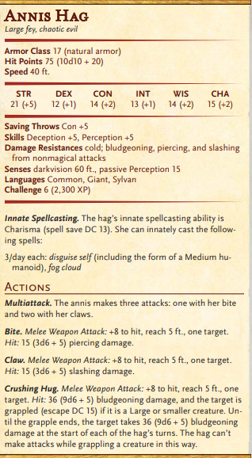 You create a 20-foot-radius [Sphere](https://roll20.net/compendium/dnd5e/Spells#h-Sphere) of fog centered on a point within range. The [Sphere](https://roll20.net/compendium/dnd5e/Spells" \l "h-Sphere)spreads around corners, and its area is heavily obscured. It lasts for the [Duration](https://roll20.net/compendium/dnd5e/Spells#h-Duration) or until a wind of moderate or greater speed (at least 10 miles per hour) disperses it.

If you go into the trees, she will use Fog Cloud (Dex Check of 18 to move between trees without missing)

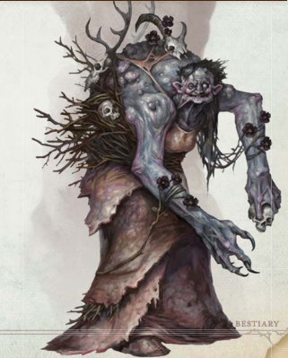

At the end of the battle, they can harvest shit, but she eventually turns into a plushy.

The leaves on the trees begin to turn orange then red then brown until they eventually begin to fall to the floor. Before they get there, however, they seem to fade away into air. The water from the waterfall begins to dry up, and the trees themselves start to fade from existence. The room itself is condensing back into it’s original shape, with the 6 chests, left open and empty.

A lever has appeared on the wall next to the door.

When the lever is pulled, you hear a loud creaking and a thump, like something large has been unlocked in the distance.

When they travel back to the jungle room, they see it just a normal sized room without a jungle or anything else.

They must pass through the small room (the changing room) and the animal carving room all the animal carvings are gone.

You pass back into the hallway, and back into the green witch room ( you may rest in the beds). The room is incredibly dark, but you don’t feel a constricting presence.

The chain has been unlocked and the gate can be raised.

You are back in the living room. The room seems to tilt from side to side and you can hear loud noises outside.

**What do you do?**

The front door remains locked unless you put the plushies on the table. If they do that, they will hear a small voice screaming “Help!” (Basil)

*also, you are like 5 stories off the ground. If you look down, you’ll see 2 giant chicken legs walking below the house*

The toad bounces away from the boggle towards the door and keeps trying to escape.

The key does unlock the trap door.

## Baba Yaga

As you enter the room, you see an old woman in front of a cauldron bobbing up and down happily as she chants something.

**\*if you inspect the pot you see little fairy parts floating\***

“Ah! You made it!” The woman cackles happily, still brewing something. “How did they do?”

Ethmerelza walks up to the old woman and says “very well, grandmother. I was very impressed”

**\*you hear little ‘helps!’ from somewhere in the room\***

* Ethmerelza is a hag in disguise.
* The plushies were spelled stuffed animals.
* Baba Yaga is friends with Celestine. They are about the same age (1000). She is a baby snatching hag, Ethmerelza is her ‘daughter’
* She wanted to
  + Get the scepter for Celestine
  + Test your abilities
  + Fill you in on the necromancer’s agreement with celestine (since he can’t)
  + Give them bane of the dead

The necromancer has found the ability to control the day, including Vampires. It’s a weak control, but she can do it.

She made a deal with celestine to help her willingly, in return for the ability to walk in the sunlight and be in running water.

He agreed to help organize some of her army in return for these ability.

HOWEVER, he doesn’t really like being controlled and is a fan of life (aka food) so he was looking for alternatives.

There was a rumor that the a scepter existed that would allow a vampire such luxuries. The scepter was in a Temple of Stone Men, however. The hand to stone trick only works on the living, so Celestine could not retrieve it, Baba Yaga only lives in Feywild, and Jade wasn’t strong enough to fight the wizard that was guarding it (he knew who Jade was).

The necromancer told him of a group of travelers that seemed intriguing. If they could get them on the dark side, the adventures could prove most useful.

Celestine wanted to see the adventurers for himself and invited them to his castle. This allowed him time to send a hoard of zombies to chase Ayana to Mt. Condor, where the relic was supposed to be. A few rumors and some inserted writing text should be enough to send the adventures to retrieve it. Once they are away from the wizard, Celestine can acquire the scepter.

Since celestine can be controlled by the necromancer, he cannot defeat her himself, but he is more than happy to help, if he gets the scepter.

“Ah, I almost forgot!” The incredibly old woman pulls a sword from a small bag hanging at her hip. “Bane of the Dead”

**Long Sword – Bane of the Dead**

Turns a beautiful pinkish white. Blade and hilt have been carved out of the crystal from the caverns

+1 bonus to attack. Strong against undead (2x damage). Weak against fey (1/2 damage).

Glows bright pink when flighting fey. Turns gray if you hit a fey with it. If you kill a fey with it, it will break.

“And” she says “I will grant you one more treat, just for fun. I will allow you to keep your animal carvings. It will allow you to turn into whatever beast form you chose for 1 hour. However, it only has one use. If you want another use, you’ll have to re-charge it.” She smiles sickly.

“You re-charge it by killing an animal of it’s type. It’s not too picky, a bear is a bear. But a Pidgeon is not a raven. Once the animal is dead, boil its heart for one hour with the animal carving in the pot. After the hour is done, drink the tea, it’s good for you.”

*continue to hear little cries for help*

“Off you go now. I think you’ll find yourself in a better position than where you started.”

*if you try to free Basil, Baba Yaga will allow you to take just the 1 fairy. Basil will beg to take more.

Baba Yaga will trade 1 dark vision eyeball for the rest of the pixies. *

When you exit the house, you find yourself right next to the spiral, glass-stone stair case.

**What do you do?**